COVER PAGE

Course code: WSOA3003A

Student number: 2152594

Name: Jodi Chapson

Assignment: Reflection and Analysis on Assignment 3

Due: 8th of April at 14:00

For this third assignment, we were required to focus on the concept of Level Design in our projects. We were instructed to construct a new prototype – or build on our old prototype from the previous assignment. I have chosen to continue building on my original prototype *Into the Dark* – and have reflected on and restructured its previous level design, with the aim of creating a play experience that would clearly introduce the core game mechanics and concepts to the player, while providing adequate space in which they can play. Hence, I present to you: *Into the Dark –* prototype 3.

In preparation for this project, I had to familiarise myself with the concept of level design and the purpose/aim of its implementation. In the context of this assignment, level design does not refer to the aesthetics or decorative aspects of videogame environments/levels. Instead, mechanical level design focuses more on the structuring of the game in support of its core mechanics and concepts. A game’s mechanics should dictate the nature of the space in which play happens, just as how the nature of the space should facilitate the actual game play. For example, if a character had the ability to move/jump, the game must provide a level/environment in which a player can make use of these mechanics of moving and jumping. If a player can attack with a weapon, there must be level elements in the game (be it an enemy, or a destructible object for example) that can be attacked or damaged, for the mechanic of attacking to be relevant. Course materials aside, I studied several case studies to understand the level design employed by the respective developers in certain published games.

One such game is *Hollow Knight* (2017), developed by Team Cherry. The game could be described as an action platformer. I investigated the beginning moments of the game within the starting area, called King’s Pass. In this area, players were introduced to the mechanics of the game for the first time, which are movement and attack. Players are first spawned into a horizontal tunnel in which they must move through to progress. Players next come across a small blockade that obstructs their progression – and are taught how to attack, to destroy and pass this obstruction. Next, the player is introduced to their first enemy – a simple ground enemy which they can kill with the attack they had just learned. Next, players encounter a small pit in the ground. Upon falling in, they are taught how to jump, to reach the other side and carry on. Then, the rest of the area is a matter of reinforcing the mechanics of movement and attack that were taught. The level area is formed of large spaces and suspended platforms which players can navigate, and more complex enemies on which they can practice their attacks. Through this starting area, players are introduced to one mechanic at a time, and each moment of learning is a new hurdle they must jump over to progress to the rest of the game.

I kept this case study in mind when revisiting the level design of *Into the Dark*. When I originally designed the starting level of this project (during the first prototype of this game), I had already begun considering ways of providing a step-by-step introduction of the mechanics to the player. *Into the Dark* is aimed to be somewhat of a dungeon-themed turn-based combat game with the main mechanics of movement (exploration), combat, with minor item collection and interaction with the environment. In terms of exploration, there is no vertical movement in this game and players simply use WASD to move around the provided dungeon floor. In terms of combat, players have 3 actions: basic attack, special attack, and flee. Special attack is an elemental ability that is only intended to be learnt later in the game – once players have understood the basic attack.

The first version of the level design can be seen in Appendix 1 and was used in prototypes 1 and 2. Players were spawned in a largely empty space in the bottom-left of the level and are required to move/explore the area to progress. Players encounter a Normal Enemy, who stands in the path between the player and the rest of the dungeon – forcing players to fight the enemy and learn how to basic attack (and flee). Upon defeating the Normal Enemy, players are given the Water Support (a small water elemental) who gives them the Water Blade ability – their first Special Attack. Venturing further into the level, they encounter their first elemental enemy – a Fire elemental. This fight is not only intended to teach players to use the Water Blade ability (as without it, they will die), but to also introduce elemental reactions to them – as Water attacks do bonus damage to Fire enemies. Defeating the fire elemental immediately ends the game.

This version skipped out on the use of locked doors and keys/collectibles due to time constraints. Hence, the mechanic of collecting items, is not properly addressed in this early version of the level. Nor is the mechanic of interacting with objects in the environment introduced (such as the use of a key to unlock a door or the picking up of an item/support). I also felt there was not enough opportunity for players to get used to combat in this version as there was only 2 enemies – one Normal Enemy and one Fire Enemy.

In this assignment, I aimed to fix the flaws I found in the original level design, (see Appendix 2 for level design of Prototype 3) by restructuring the level to give more opportunities for players to test out and experiment with the mechanics. At the start, players are dropped in a similar open area to previous versions – and are required to move around and explore the place. There is a dead end with only one Normal Enemy in the generally empty area. Players must use Basic Attacks to defeat it – after which a new area will open to them. The new area hosts another Normal Enemy. Unlike the previous enemy, this one is completely optional as there is space to move around it. However, players can fight it to not only practice basic attacks, but to also try out their newly obtained Water Blade attack on this easy-to-defeat enemy. This area also features a locked door that blocks the way to the final area. Upon further exploration, players will find a key. With this key, players can approach the door and will be prompted to press E to interact with it (and hence unlocking it). This was intended to encourage exploration and teach the significance of keys and their corresponding locked doors. The final area holds a Fire Elemental – a significantly harder enemy to defeat. Unlike when a player uses Water Blade on a Normal Enemy, Water Blade does significantly more damage if used on the Fire Elemental – as will become evident in this battle. This fight was aimed to showcase elemental reactions and the importance of choosing your attacks carefully – as different elemental attacks will have different elemental effects. Upon defeating the enemy, it drops another Key – reinforcing the use of keys on locked doors, that was introduced in the previous area. This final door opens to a dark corridor. Going into it, ends the game.

In reflection, I felt that this newly reconstructed design of the level was an improvement from that of the previous prototypes. I felt it offered a much larger space for players to explore, in the sense that there were more opportunities for combat and more actual room to move in. This version also introduces mechanics that the previous versions failed to do due to time constraints – such as the use of keys and locked doors. This version also better demonstrates the use of the Water Blade, as players have an opportunity to test it out on both Normal and Elemental enemies. The concept of elemental reactions is intended to be a big part of the game should it be developed further – and hence it was important that it be introduced properly to the player. However, I felt that still, more content could be added to the level – to allow players even more space and opportunities to test their newly learned actions, and to further encourage exploration.

However, as of now, this is the end of Prototype 3 – Level design.

References

Team Cherry. (2017). Hollow Knight (PC Version) [Video game]. Adelaide, Australia: Team Cherry.

APPENDIX 1

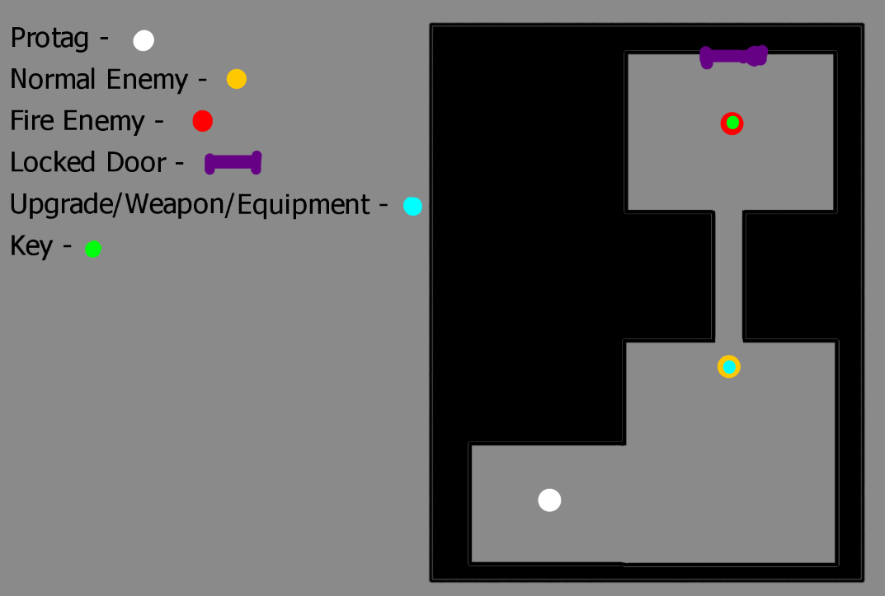

Appendix 1: Protype 1 and 2 Level Design

APPENDIX 2

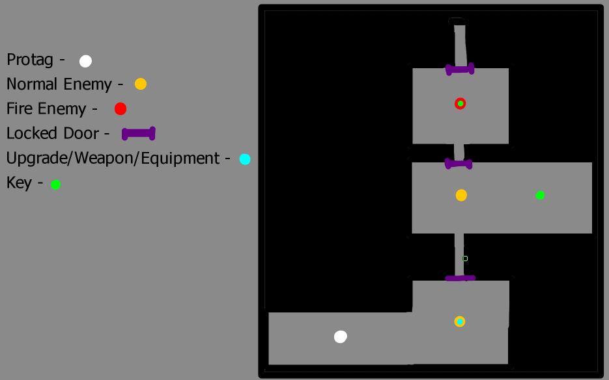

Appendix 2: Protype 3 Level Design